Site Assessment Tool – Methodological note
EUAA practical tool for the assessments of sites and buildings for (potential) reception facilities
September 2025

Contents
List of abbreviations 2
1. Introduction 3
1.1 The site assessment workflow 4
1.2 Who should use the SAT 5
2. Assessment phases 6
2.1 Desk-based assessment 6
2.2 On-site assessment 7
3. Filling in the site and building assessment sections 7
3.1 How the criteria’s work 7
3.2 Working together in the SAT 8
3.3 Site assessment sections 8
3.4 Building assessment sections 10
4. Evaluation, recommendations and reports 11
4.1 Evaluation 11
4.1.1 Recommendations 12
4.2 Report generation and report comparison 12
5. Conclusion 13

List of abbreviations
Abbreviation | Definition
CEAS | Common European Asylum System
EUAA | European Union Agency for Asylum
EU | European Union
EU+ countries | EU Member States plus Iceland, Liechtenstein, Norway and Switzerland
Member States | EU Member States
RCD (2024) | reception conditions directive — Directive (EU) 2024/1346 of the European Parliament and of the Council of 14 May 2024 laying down standards for the reception of applicants for international protection (recast)
SAT | Site Assessment Tool

- Introduction
Within the framework of the established Modular Approach to Reception, the European Union Asylum Agency (EUAA) has developed a range of tools designed to support the national authorities of EU+ countries in managing the infrastructural aspects of reception more effectively. The Site Assessment Tool (SAT) is one such practical tool, supporting EU+ countries to identify new reception sites and to improve reception sites to accommodate applicants for international protection according to EU standards.
Assessing potential sites and existing buildings in view of the reception of applicants requires authorities to navigate a wide range of requirements. Often this entails working under time pressure, coordinating input from various experts, addressing operational issues and ensuring compliance with both national and EU legislation – including the new reception conditions directive (RCD (2024)) () as it stipulates that housing provided in kind must ensure an adequate standard of living for applicants ().
Not every location is equally suitable for reception purposes. Various technical, environmental and infrastructural factors must be considered. The SAT can be used to assess any type of site intended for the reception of applicants. This applies regardless of the site's purpose or procedural stage, including i.e. sites used for regular asylum procedures, asylum border procedures or second-line reception.
The SAT was developed to meet the need for a structured, fast and practical approach to this process. The tool was created together with the dedicated working group on composed of architects, engineers and site planners from EU+ countries, all with experience in site design and/or infrastructure within reception systems. This digital tool enables the fast assessment of sites, buildings and related infrastructure. It provides a user-friendly way to gather, organise, and compare all relevant data efficiently. It can also be used through a mobile app and should be accessible to all experts involved in the assessment process. This methodological note further outlines how the SAT should be used in practice and what its functionalities are, ensuring that all users are well informed and equipped to make full use of this resource.
  - The site assessment workflow
The SAT should be used within the broader workflow of site assessment (see Figure 1 below). The process begins with the definition of reception needs and the pre-identification of potential locations that may meet those needs. This includes:
- specifying the required reception capacity (i.e. number of people to be accommodated);
- clarifying the intended purpose of the site in terms of:
  - procedure: for example, whether it will serve as a registration centre, a border procedure facility, a Dublin centre, or another specific function;
  - profile of the applicants: for example, whether it will be hosting unaccompanied minors, families or other groups based on specific vulnerability criteria.
Once the sites and/or buildings have been shortlisted, the SAT guides the assessment.
The tool supports structured data collection in the field, the inclusion of visual documentation, and the consolidation of input from multiple assessors. It supports both desk-based and on-site assessments. Using predefined criteria and taking into account all essential technical and legal factors relevant for reception facilities, the tool provides a suitability evaluation for both sites and any existing buildings. Finally, the SAT also enables users to generate a report that includes key findings, recommendations and, where applicable, proposals for necessary interventions.
Authorities and decision-makers can use the final report to plan, construct or adapt reception facilities. Where necessary, the report can inform follow-up in-depth feasibility studies. When several locations are under consideration, the reports can be used to compare different sites and support informed decisions to select the most suitable option.
Figure 1. Site Assessment Workflow
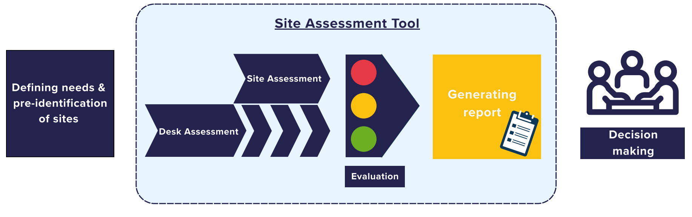
  - Who should use the SAT
The SAT is designed to be used collaboratively by a multidisciplinary team of assessors who can bring together the technical and contextual knowledge required to assess (potential) reception sites and/or buildings.
Ideally, a site assessment team should include professionals with complementary expertise, as follows.
- An engineer who can evaluate the technical feasibility of the site or building, including structural aspects, utilities and connection to essential infrastructure such as water, electricity, sewage, etc.
- An architect who can assess the suitability of existing buildings or plots for conversion or development, considering spatial planning, design, accessibility (for applicants with special needs) and overall functionality.
- A reception expert from the national authority or a supporting actor (such as the EUAA), with expertise in operational reception needs and national/EU legal requirements
- , who ensures that sites and buildings meet EUAA standards on reception and provide an adequate standard of living for applicants for international protection ().
- A professional with in-depth knowledge of the local and administrative context, who can contribute with insights on land ownership, urban planning regulations, environmental constraints, local services and any other factors that may affect the viability and sustainability of the site. Ideally, this person should have a procurement background and possess a solid understanding of local costs to ensure accurate feasibility assessments.
Depending on the governance model and resources of each Member State, the assessment team may be composed of internal staff from national authorities or external experts contracted to carry out the assessments. In either case, it is essential that all stakeholders involved have access to the tool and to this methodological note.
- Assessment phases
  - Desk-based assessment
The tool includes an option to select ‘desk assessment’ as the working modality. A desk assessment consists of the review and analysis of all available documentation related to the site and/or any existing buildings.
This preliminary step enables assessors to understand all the parameters linked to the site/building, identify potential constraints that may affect the suitability of the location, determine whether an on-site visit is needed, and better prepare for fieldwork by focusing on specific areas of concern. Relevant documentation typically includes:
- land rights certificates;
- soil certificates;
- site plans;
- building permits;
- aerial images or photographs;
- information on nearby services (e.g. schools, hospitals, public transport).
It may also include technical documentation such as electrical and HVAC () plans, installation certificates and details of connection to essential infrastructure like potable water, sewage and electricity.
A checklist is provided within the SAT to support this process, and all documents can be uploaded directly into the tool. However, it is strongly recommended to also store them outside of the tool for example, in a dedicated folder on your device or shared drive. Once the final report is generated the uploaded documents can no longer be accessed through the tool, so having a separate, organised location ensures easy access if others need to review them later.
As the collection of documentation may take time (and may depend on external actors sharing information), the desk assessment is often done in parallel with the on-site assessment, rather than in advance.
  - On-site assessment
Once most of the desk assessment has been initiated or completed, an on-site assessment is carried out to verify and complement the information gathered. This allows assessors to physically look upon the different elements (such as space, access, landscape, risks etc.). The SAT has a functionality to upload photos and videos taken during the site visit. For added convenience and practicality in the field, assessors are encouraged to access the SAT on their mobile device ().
- Filling in the site and building assessment sections
  - How the criteria work
The assessment is organised in sections that guide the assessor through key assessment criteria. In each section it is possible to select predefined options (tick boxes), add comments or observations, and upload supporting documents, photos or videos. After filling in each section, it is important to save the section before moving on. To support assessors in completing each section accurately and efficiently, the tool includes a number of practical features, as detailed below.
- To support accurate data entry, criteria include prefilled units of measurement where applicable. This helps users enter values in the correct format and reduces errors.
- To help users filling in certain criteria, an ‘’'(Information) icon provides more detailed descriptions, practical guidance and suggestions on how to obtain the necessary information. | 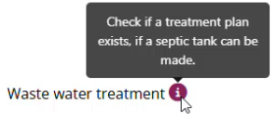
- For certain critical or potentially disqualifying factors, a red flag icon alerts assessors to the high risks or necessary considerations when deciding on suitability. The tool includes 11 red flags in the site assessment’s part and 2 in the building assessment’s part. | 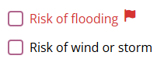
  - Working together in the SAT
Collaborative work is a key feature of the SAT. Multiple assessors can contribute at the assessment from different places at a different time.
Two collaboration modes are available in the SAT. Assessors can select any once all required fields in Section 1 are completed and the option to generate the assessment file (JSON) becomes available. The collaborative mode can be enabled through the menu at the bottom of the website.
Assessors work sequentially on the same assessment, passing on the assessment file once their part is complete so the next person can upload it on the tool. With the exception of Section 1 on the information of the assessor, if previous answers are modified, the most recent version will overwrite earlier inputs.
Assessors can work in parallel by using separate versions of the assessment file, and later merge their inputs into one consolidated assessment file. During the merging process, the tool separates entries using a semicolon ‘;’ between sentences; users are prompted to select the sections to combine.
Importantly, some questions only allow a single answer (e.g. Yes/No).
The SAT also offers a multiple-column format for users to compare reports at a later stage in the assessment phase. This comparison view displays inputs side by side but does not allow any edits. While it is typically used to compare different sites, it can also be useful for comparing inputs from multiple assessors, especially for questions that only allow one answer (e.g. Yes/No).
  - Site assessment sections
In the assessment, it is recommended to first evaluate the site and then move on to any existing buildings. Although simultaneous assessment is possible, it is recommended that buildings should always be assessed only after a site assessment, maintaining the rationale that a building exists on a site, therefore, site suitability is a prerequisite for any potential use of existing buildings.
The SAT is composed of the sections below.
 | - General Information  Offers fields to enter administrative details about the assessor and the site, such as the address, ownership status, and any land rights or usage permits.
 | - Size  Offers fields to note the space available on the site. Assessors can also upload photographs or videos to visually document the space.
 | - Site Topography, Environment and Soil  Allows assessors to describe the site’s terrain, elevation, vegetation and soil conditions.
 | - Natural and Manmade Hazards  Enables input on any known risks or hazards, including natural threats (e.g. flooding, soil contamination) and manmade risks (e.g. proximity to highways, railways).
 | - Wildlife and Domestic Use  Offers fields to document the site’s current use, including whether it is located in or near hunting areas or whether there are any animals that may be protected on site.
 | - Security and Surroundings  Supports the input of information on the broader surrounding of the site (e.g. proximity to war zones) and security risks like the accessibility for emergency services such as ambulances and fire brigades.
 | - Infrastructure and Supplies  Allows assessors to record the availability and condition of infrastructure, such as potable water supply, electricity, sewage and waste disposal.
 | - Services  Supports the input of information on local services available to potential residents, including education, healthcare, shops, and public transport.
 | - Compensation and Inclusion  Offers fields to describe how the presence of a reception site might affect or engage the local community, such as through job creation or the provision of shared services, supporting social inclusion.
 | Site Evaluation
  - Building assessment sections
Within the Manage Buildings section, assessors can register and assess one or more buildings located within the site. Each building is added individually, is assigned a specific name, and is assessed separately. Once registered, buildings appear in a list view under ‘List of all registered buildings’, allowing assessors to view and manage multiple buildings side by side.
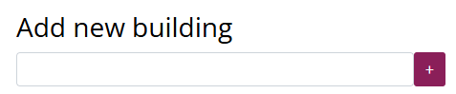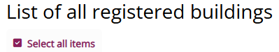
 | - General Details of the Building  Offers fields to enter basic information about the building, e.g. its former use, gross surface, number of floors or extension possibilities.
 | - Basic Structural System  Allows assessors to specify the building’s main construction type.
 | - Structural Issues and Hazards  Used to document any visible signs of damage or deterioration, such as cracks, pest infestation or structural wear that may affect safety or usability.
 | - Relevant Existing Technical Installations  Offers fields to list existing mechanical and electrical systems, including heating, ventilation, air conditioning, CCTV, fire alarms, and other installed systems.
 | - Roof  Offers fields to note down the condition of the roof and report issues such as leaks and structural integrity.
 | - Evacuation Measures  Records the presence and adequacy of escape routes, including horizontal and vertical evacuation options and compartmentalisation.
 | - Climate Suitability  Offers fields to document the insulation of the building and the presence of a temperature regulation system.
 | - Light and Ventilation  Offers fields to assess whether the building has sufficient natural light and ventilation in different rooms.
 | - Limitations for Persons with Disabilities  Captures any barriers to accessibility, such as doorways, access to sanitary facilities, other floors, and whether any adaptations are in place.
 | - Existing Rooms  Records the presence, size, and condition of rooms, such as i.e. bedrooms, offices, storage areas, bathrooms, kitchens and showers.
 | - Furniture  Allows input on whether any furniture is present and whether it meets basic fire-resistance standards.
 | Building Evaluation
Disclaimer:
All data entered into the SAT is stored locally and offline. It is not transmitted or shared externally and is only accessible to the assessors involved in the evaluation process.
- Evaluation, recommendations and reports
  - Evaluation
The evaluation is not an automated process. It is the responsibility of the assessment team to draft and determine the final evaluation based on their professional judgement.
At the end of the site assessment and at the end of the building assessment, the assessment team will formulate an evaluation based on a ‘traffic light’ system whereby, empty sites or existing buildings are classified as follows.
- Not suitable: i.e. when the team considers that the empty site or existing building cannot, in any manner whatsoever, be used or transformed for accommodation purposes. In this case, the tool requires to give reasons of the non-suitability of the site or building.
- Suitable with major interventions required: i.e. when the assessment team considers that the empty site or existing building can be used or transformed for accommodation purposes only if appropriate measures are taken, such as work interventions. In this case, the assessment team would need to provide a detailed description of the interventions deemed necessary, an estimation of costs and duration for the required interventions.
- Suitable: i.e. when the assessment team considers that the empty site or existing building can be used or transformed for reception accommodation purposes without major interventions required.
    - Recommendations
At the end of the evaluation section, the SAT provides a field to write recommendation(s) for decision-makers on the potential use of the site and/or its buildings.
The recommendation(s) drafted by the experts using the tool should mention for instance that the decision makers should keep in mind particular key findings, including any necessary modifications or constraints that may affect the site's suitability for reception. Where relevant, each section should also include an indication of potential costs, allowing for a rough estimation of the budget that decision-makers should take into account.
  - Report generation and report comparison
Once all required fields in Section 1 are completed, assessors can generate and save the assessment file in their device. To generate a report, the steps below are to be followed.
- Upload your previously saved assessment file under the ‘Report Generation’ section.
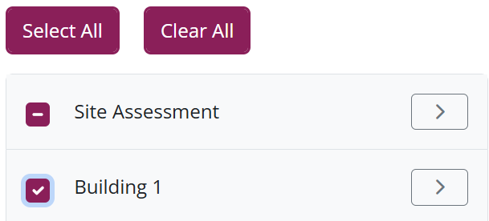
- Choose the items to print, such as specific sections of the site assessment and whether to include any of the buildings (and which sections). Regardless of these choices, the report will always contain the general site information (Section 1 in ‘Site Assessment’).
- Click ‘Print Report’ to generate the final version. This will provide the users with a PDF file of the report to download or print.
The final evaluation and recommendations are highlighted in blue for visibility t in the final report. When sections are included but not filled in, their columns will be blank, indicating which information is missing in the report.
This comparison feature can help authorities make informed decisions when selecting the most suitable option. This feature can also be used if several assessors have filled in the same section and they want to see it in columns next to each other.
- Conclusion
The SAT supports the initial evaluation of sites and buildings for potential use as reception facilities. It brings together the relevant assessment content into a single, structured document, which is the main output of the SAT. This report is intended to support authorities in determining whether to plan, construct, or adapt a reception facility. As a rapid assessment tool, the SAT only provides a preliminary overview. At the end of the assessment, if visited sites/buildings are considered to be feasible for reception purposes, a more in-depth study can be conducted to determine financial elements (i.e., costs for transformation) and to provide an estimate of necessary investments and time needed for the reception centre to become operational.
This methodology outlines how to apply the SAT. For detailed guidance on the tool’s features and use, refer to the SAT User Manual.

() Directive 2013/33/EU of the European Parliament and of the Council of 26 June 2013 laying down standards for the reception of applicants for international protection (recast), (OJ L 180, 29.6.2013).
() The EUAA has developed non-binding practical guides and operational standards and indicators, which offer Member States concrete guidance on what can be considered adequate reception conditions. Member States have to take these into account to help ensure that reception conditions remain consistent with the Common European Asylum System (CEAS).
() The standards and indicators for reception are outlined in the following publications: EUAA, Guidance on Vulnerability in Asylum and Reception: Operational standards and indicators, May 2024; EASO, Guidance on Reception Conditions: Operational standards and indicators, September 2016; and EUAA, Guidance on Vulnerability in Asylum and Reception: Operational standards and indicators, May 2024. These documents are currently under revision to align with the Pact with a new edition expected in early 2026.
() Heating, ventilation and air conditioning.
() If mobile access is difficult on site, it is possible to generate and print an empty report by first creating an assessment file and then proceeding to ‘Generate Report’ (see Section ‎4.2 for more details).

